**The Impact of ADHD on Labor Market Success: Exploring Factors and Implications**

Isaiah Raymundo Gonzalez

Economics 205-Workshop in Policy Analysis,

Spring 2023

Dr. Patralekha Ukil

TABLE OF CONTENTS  
0 Abstract:................................................................................................. 3

1 Introduction:........................................................................................... 4  
2 Literature Review:...................................................................................5  
3 Method .................................................................................................. 8  
4 Data ....................................................................................................... 10  
5 Results ................................................................................................... 11  
6 Conclusion ............................................................................................ 14  
7 References.............................................................................................. 16  
8 Tables and Graphs....................................................................................18

**Abstract**

Attention-deficit/hyperactivity disorder (ADHD) is a neurodevelopmental condition that affects individuals across the lifespan. While significant research has been conducted on the cognitive and behavioral aspects of ADHD, there is a scarcity of studies examining its influence on long-term career outcomes. This study aims to fill this gap by investigating the association between ADHD and career success, as measured by income and employment status. Using a fixed effects modeling approach, this research analyzes panel data from a diverse sample of individuals over a specified time period. By accounting for individual-specific unobserved heterogeneity and controlling for time-invariant factors, the fixed effects models provide a robust framework to examine the relationship between ADHD and career success. Preliminary findings suggest that individuals with ADHD may experience challenges in their career trajectories. The results indicate a negative association between ADHD and both income and employment status, indicating potential barriers to career advancement for individuals with ADHD. However, further analysis is needed to explore the specific mechanisms through which ADHD influences career success, such as cognitive functioning, executive functioning, or workplace accommodations. Understanding the impact of ADHD on career success has important implications for both individuals and society. By identifying the barriers faced by individuals with ADHD in the labor market, policymakers and educators can develop targeted interventions to support their career development and enhance their overall well-being. This study contributes to the growing body of literature on ADHD and its implications for occupational outcomes, shedding light on the factors that shape career trajectories for individuals with ADHD and informing strategies for promoting their long-term career success.

**Introduction**

Attention-deficit/hyperactivity disorder (ADHD) is a prevalent neurological developmental disorder affecting a great deal of children and adults. Despite the extensive research conducted on ADHD, there remains a significant knowledge gap as to the economic ramifications experienced by adults diagnosed with ADHD later in life. This study aims to fill this gap by investigating the influence of ADHD on both employment probabilities and wages among adults, comparing people with ADHD to those without the disorder. By shedding light on these crucial aspects, I can gain a deeper understanding of the economic consequences of ADHD. According to economic theory, human capital accumulation is a key determinant of earnings. Human capital is acquired through formal education, work experience, and on-the-job training. However, people with ADHD may face difficulties in acquiring human capital due to their symptoms, which can lead to lower earnings. To my knowledge, few studies have examined the relationship between ADHD and earnings using longitudinal data that accounts for human capital accumulation over time.

The economic impact of ADHD is not limited to lower earnings but also extends to educational attainment and job performance. This disorder can have broader economic implications for both individuals and society. By shedding light on the relationship between ADHD and earnings, this paper can help raise awareness of this issue and contribute to efforts aimed at improving the lives of individuals with ADHD and reducing its economic burden. This issue could be of interest not only to those directly affected by ADHD but also to policymakers, employers, and the public who may be concerned with issues related to productivity, workforce development, and social welfare.

The research aims to explore the variables associated with adults diagnosed with ADHD and their impact on work labor success, specifically income and employment status. To achieve the goals of this paper, I will use the American Community Survey (ACS) samples from 2008-2020 to create a dataset that explores the expected variables of adults with ADHD. The first section will examine existing literature and research on the advantages or disadvantages of ADHD and any factors that may potentially influence the likelihood of work labor success. The next section will consist of data, and the methods of the data created from the ACS survey. As well, this section will also explore why specific variables and methods were selected and the rationality behind such. The final section will discuss the revisions of the experiments and the discussions of significant findings.

**Literature Review**

Research has consistently shown that individuals diagnosed with ADHD have lower educational attainment, reduced earnings, and poorer employment outcomes compared to their non-ADHD peers (Dalsgaard et al., 2015; DuPaul et al., 2016; Langberg et al., 2018). These findings suggest that ADHD poses significant challenges for individuals in the labor market, potentially due to difficulties with executive functioning, time management, and organizational skills. Despite these challenges, research suggests that age of ADHD identification may play a role in long-term success in the labor market. A study by Fabiano et al. (2006) found that individuals with ADHD who were diagnosed and treated earlier in life were more likely to have successful academic and occupational outcomes later in life. This fact suggests that early intervention and treatment for ADHD may help mitigate some of the challenges people with ADHD face within the labor market.

An important factor to consider when examining success in the labor market among individuals with ADHD is the age of identification. Several studies have shown that early identification and treatment of ADHD is associated with better academic and behavioral outcomes (Chronis-Tuscano et al., 2013; Pelham et al., 2014). However, little is known about the long-term effects of the age of identification on success in the labor market. A study by Bruchmüller et al. (2012) found that early identification and treatment of ADHD was associated with improved social and emotional functioning in adulthood, which may also be contributing to success in the labor market.

Gender differences in ADHD have been reported in several studies, with males being diagnosed more frequently than females (Nigg, et al., 2016). However, the impact of gender on success in the labor market among people with ADHD is not well understood. A study by Antshel et al. (2019) found that female participants with ADHD had lower levels of educational attainment and were less likely to be employed than their male counterparts. This eventuality highlights the need for more research into the impact of gender on success in the labor market among people with ADHD. Similarly, there is limited research on the impact of race and ethnicity on success in the labor market among individuals with ADHD. However, studies have shown that racial and ethnic minorities are less likely to receive a diagnosis of ADHD and less likely to receive appropriate treatment compared to their non-minority peers (Daley et al., 2018; Rastogi & LaRoche, 2017). This response suggests that disparities in ADHD diagnosis and treatment may contribute to disparities in success in the labor market among racial and ethnic minorities with ADHD.

Individuals with ADHD face several challenges when it comes to employment and success in the labor market. According to Loe and Feldman (2007), individuals with ADHD may struggle with certain work-related skills such as time management, organization, and impulse control. These skills are important for success in several industries, particularly those that require strict adherence to schedules or rely on repetitive tasks. Furthermore, individuals with ADHD may also struggle with social skills, which can impact their ability to network, communicate effectively with colleagues and clients, and overall job performance (Barkley, 2014).

Moreover, individuals with ADHD may face additional challenges, including potential biases in the hiring process. This study breaks new ground by investigating the association between ADHD symptoms in childhood (at age 10) and labor market outcomes in adulthood (ages 26-46) for a cohort of 17,196 individuals born in April 1970. It also examines the impact of childhood circumstances at birth and academic performance at ages 10 and 26 on these relationships. The results reveal that higher levels of childhood ADHD symptoms, indicated by a one standard deviation increase, are linked to a reduction in employment rates by up to two percentage points and income by up to four percentage points. Notably, nearly half of the variation in employment outcomes can be attributed to disparities in academic performance at age 10, underscoring the potential significance of educational interventions in schools (Moffitt et al., 2011).

When it comes to comparing employment and wage means of individuals with and without ADHD, research has yielded mixed results. A study by Kessler et al. (2005) found that individuals with ADHD were less likely to be employed and had lower earnings compared to individuals without ADHD. However, a more recent study by Dalsgaard et al. (2015) found no significant differences in employment rates or income between people with and without ADHD.

It is worth noting that there may be additional factors that impact success in the labor market for individuals with ADHD, such as race and gender. A study by Barbaresi et al. (2013) found that while individuals with ADHD were less likely to have completed high school and attended college, this disparity was particularly pronounced for females and individuals from racial and ethnic minority groups. This fact suggests that there may be unique challenges and barriers to success within the labor market for these groups of individuals with ADHD.

This literature review has highlighted the many challenges that individuals diagnosed with ADHD may face in the labor market. Lower educational attainment, reduced earnings, and poorer employment outcomes have been consistently observed among individuals with ADHD. Furthermore, the age of identification, gender, and race/ethnicity may also play important roles in determining success in the labor market among individuals with ADHD. Further investigation is warranted to gain deeper insights into these factors and devise impactful interventions aimed at enhancing the long-term prospects of individuals with ADHD in the labor market.

**Method**

To address the research questions that were highlighted in the introduction, this study will use two Ordinary Least Squares (OLS) regression models. The first model will examine the effect of ADHD on employment status, with employment status as the dependent variable and ADHD status, age, gender, race, education, income, insurance status, and marital status as independent variables. The second model will examine the effect of ADHD on income, with income as the dependent variable and ADHD status, age, gender, race, education, insurance status, and marital status as independent variables.

Data for this study was obtained from the National Health Interview Survey (NHIS) database from 2008-2020. The NHIS is a nationally representative survey that collects information on a variety of health-related topics, including mental health and employment. The sample for this study will include all adults aged 18 and older who participated in the NHIS and have complete data on the relevant variables. The OLS models will be estimated using statistical software, mainly R and RStudio. The coefficients for each independent variable in the models can be interpreted as a possible change in the dependent variable that will be associated with a one-unit increase in the independent variable. This interpretation assumes that I hold all other variables constant. Furthermore, significant tests will be used to see if the coefficient is significant and therefore impactful.

For the first OLS model with employment status as the dependent variable, I chose this variable because it is a key indicator of the economic impact of ADHD on adults. Previous research discussed in the literature review section of this study has already shown that individuals with ADHD may have difficulty with job performance, which leads to unemployment or underemployment. By examining the effects of ADHD on employment status, one can better understand the economic burden of this disorder on individuals and society. In addition, I included several independent variables in my model that I believe are to be relevant to human capital accumulation and employment outcomes, such as education level, income, insurance status, and marital status. These variables are likely to affect employment status directly or indirectly and controlling them can help us isolate the effects of ADHD on employment outcomes. I also included demographic variables such as age, gender, and race to control for potential confounding factors.

For the second OLS model with income as the dependent variable, I chose this variable because it is a key indicator of economic success and is closely linked to human capital accumulation. Individuals with higher incomes are likely to have acquired more education, work experience, and on-the-job training, all of which are key determinants of earnings. By examining the effects of ADHD on income, it can better understand how this disorder may affect the accumulation of human capital and the economic well-being of individuals.

The estimating equations for the four regressions are as follows:

Model without fixed effects:

Employment Status = β₀ + β_(­1)ADHD + β₂AGEi + β₃GENDER_(i) + β₄RACE_(i) + β₅EDUCATION_(i) + β₆INSURANCE_(i) + β₇MARRIED_(i) + ε_(i)

Income = β₀ + β₁ADHD + β₂AGE_(i) + β₃GENDER_(i) + β₄RACE_(i) + β₅EDUCATION_(i) + β₆EMPLOYMENT_(i) + ε_(i)

Model with fixed effects:

Employment Status = β₀ + β₁ADHD + β₂AGE_(i) + β₃GENDER_(i) + β₄RACE_(i) + β₅EDUCATION_(i) + β₆INSURANCE_(i) + β₇MARRIED_(i) + β8STATE_(i) + ε_(i)

Income = β₀ + β₁ADHD + β₂AGE_(i) + β₃GENDER_(i) + β₄RACE_(i) + β₅EDUCATION_(i) + β₆EMPLOYMENT_(i) + β₇STATEi + ε_(i)

Overall, I believe that these variables are a good fit for my analysis because they are theoretically relevant to the economic impact of ADHD and have been used in previous research on this topic. By controlling these variables, I can isolate the effects of ADHD on employment and income outcomes and provide a more nuanced understanding of the economic burden of this disorder. The goal of this study aims to add to the existing literature on the economic and financial impact of ADHD on adults. By examining the effects of ADHD on employment status and income, this study can shed light on the challenges faced by individuals with ADHD in the workforce and inform efforts to improve their economic outcomes.

**Data**

The dataset comprises a balanced panel of six individuals observed across 98 time periods, resulting in a rich dataset with a total of 603,794 observations. The linear regression model that I ran is a fixed-effects model that includes both individual-specific effects (fixed effects) and time-invariant covariates. However, the first model I ran were basic linear regression models. Based on the output, the model fails to display a significant proportion of the variation in the dependent variable, Family Income. The basic linear regression with income as the dependent variable reveals an adjusted R-squared of 0.3732. This score indicates that the model explains about 37.32% of the variation in Family Income (INCFAM07ON). However, I also committed to a basic linear regression model using Employment status as the dependent variable and it had a marginally better adjusted R-Square of 0.4029. Both models had their variables significant except for “black” in the income model and “native” in the employment model. For this study, I didn’t consider anything statically significant that was above 0.10. A p-value less than 0.10 indicates that the covariate is statistically significant, while a p-value greater than 0.10 indicates that the covariate is not statistically significant. The only variables that shared the same signs for the models were Sex, White, and Married. Other than these the signs of the coefficients were different for the models. Employing a studentized Breusch-Pagan test for both models we see that the p-values are far below a significance level of .05. These results allow us to reject the null hypothesis which means that there is heteroscedasticity is present in our data so unfortunately our residuals are not distributed evenly. To combat these two methods was attempted to transform the data into homoscedasticity residuals.

The first method is using weighted regression. Weighted regression is a statistical technique employed to address heteroscedasticity or uneven variances in the errors of a regression model. While ordinary least squares (OLS) regression treats each observation equally, assuming constant error variance, this assumption may not hold true in certain scenarios. Heteroscedasticity occurs when the variability of errors varies across observations, challenging the assumption of homoscedasticity. Weighted regression tackles this issue by assigning different weights to observations based on their estimated precision or variability in the response variable. By assigning higher weights to observations with greater precision (lower variances) and lower weights to those with lower precision (higher variances), the weighted regression model adjusts parameter estimates to give more importance to observations with smaller variances and less weight to those with larger variances. This approach helps mitigate the impact of observations with higher variability, preventing them from dominating the analysis. Various weighting schemes can be employed in weighted regression, such as inverse variance weighting, where weights are inversely proportional to the variances of errors. The choice of weighting scheme depends on the specific characteristics of the data and the research question at hand. Weighted regression is particularly valuable when dealing with heteroscedasticity, enabling more accurate estimation of regression coefficients, and enhancing the validity of statistical inference. The second method was simply logging the non-dichotomous variables.

**Results**

I now move on to the models that will lead to our conclusions with model 3 where we examine the fixed effects model. Model 3 is a basic fixed effects model with income as its variable. The model uses the demeaned approach and uses occupation and years as its fixed effects. The model ends up displaying an exceptionally low R-squared value of 0.03864. The findings strongly suggest that the current model falls short of capturing a good deal of variability in the dependent variable. This implies the presence of unaccounted variables or factors that could wield a noticeable influence on the outcome. Upon scrutiny of the coefficients, it becomes evident that several variables exhibit a noteworthy impact on the dependent variable. ADHD has the strongest impact with a coefficient of -6.244, indicating that with a diagnosis in ADHD, there is an expected decrease of $6,244. in income. Correspondingly, Gender (Sex), and being of Black descendants has a negative impact on income.

On the other hand, the number of children (NCHILD), marital status (MARSTAT), gender (SEX), employment status (EMPSTAT), education (EDUC), age, and being of white, Hispanic, or Asian background has a positive impact on income, with each unit increase leading to an increase in income. Interestingly, the Native American race was found to have no statistically significant impact on income in this model. However, it is important to note that the Breusch-Pagan test indicated that there is a heteroscedasticity in the residuals even after the attempt of adding weighted residuals and the attempt to log the variables. The state of the Breusch-Pagan test suggests that the model may not fit the data well and should be interpreted with caution. Overall, these initial results suggest that while there are some significant variables impacting income, there are likely other factors that have not been accounted for and may need to be included in the model to improve its predictive power.

To fix these issues, I decided to try to transform my tests and data. One approach I tried was transforming some of the continuous predictor variables, such as age or education, to see if it improved the relationship with the outcome variable. However, I found that the transformations did not lead to a significant improvement in the model fit. Another approach I took was to include additional predictor variables that may be relevant to the outcome variable but were not included in the original model. Prior I did not have all these included variables such as employment status, occupation, or income. I added these variables to increase the R-square and help alleviate the heteroscedasticity issue. While these variables did show some improvement in the model fit, the R-squared value remained relatively low.

It is at this point that I attempt to switch gears or a bit and go back to using employment status as my dependent variable. While in Model 4 we see a slightly better r square than its previously regression model the variables do not make any sense with what we know to be true. It makes claims such as being older, having higher education , and having health insurance coverage makes one less likely to be employed. All of which do not make sense when comparing it to common knowledge and peer review journals. It is for this reason that I choose to drop the models using employment as an important model. Another problem could be endogeneity. Employment status can be endogenous, meaning it may be influenced by other variables in the regression equation. For example, factors such as education, age, or health conditions can simultaneously affect both employment status and other independent variables. This can lead to biased coefficient estimates and incorrect inferences. Another issue could have been multicollinearity. Employment status may be highly correlated with other independent variables in your regression model, leading to multicollinearity. This can make it challenging to interpret the individual effects of each variable accurately.

To explore the potential improvement of my fixed effects model I decided to add ADHD as an interaction term into my regression model across different racial and ethnic groups. (Model 5). Specifically, I included the interaction between ADHD and various racial or ethnic categories, such as White, Black, Hispanic, Native American, and Asian. This allowed me to examine whether the relationship between ADHD and the outcome variable varied among individuals from different racial or ethnic backgrounds. To estimate the regression model, the within estimator is employed. The findings reveal that individuals with ADHD experience a negative impact on their employment income, while factors such as education level, age, and marital status positively influence income. Moreover, the analysis uncovers racial disparities in income, with being white, Asian, or Hispanic associated with higher income levels, while being black or Native American is linked to lower income. The investigation also explores the interaction effects between ADHD and race, revealing a significant negative interaction between ADHD and white race. These outcomes underscore the significance of developing targeted interventions to support individuals with ADHD in the labor market. Additionally, the study emphasizes the need to address and understand racial disparities in employment outcomes.

So , while I attempted to improve the model fit by transforming variables and adding additional predictors, I was unable to substantially increase the fit however I was able to marginally increase the R-square in a few models. This event suggests that there may be other factors that are driving income variation in the dataset that are not captured by the current model. Further research and data collection may be needed to fully understand the complex relationships between income and the predictor variables.

**Conclusion**

In this analysis, I explored the relationship between income and various demographic and socioeconomic factors such as ADHD, health insurance coverage, employment status, education, race, number of children, marital status, gender, and age. The research question was to determine how these factors influence income and whether the model could accurately predict income. The first model had a very low R-squared value of 0.03864, indicating that it did not explain much of the variation in income. I also found evidence of heteroscedasticity in the residuals, suggesting that the model may not fit the data well and should be treated with caution. To improve the model, I tried several techniques such as transforming continuous variables, adding new predictor variables, and using interaction terms, but none of these methods resulted in a significant improvement in the R-squared value. Despite the limitations of the model, the analysis revealed several significant predictors of income. Health insurance coverage, employment status, education, number of children, marriage status, and specific races were found to have positive effects on income, indicating that individuals with these characteristics tend to earn higher incomes. On the other hand, ADHD, gender, and specific races (Native American and Black) showed negative effects on income, suggesting that these factors may pose challenges or constraints in achieving higher income levels. Interestingly, the analysis did find a statistically significant effect of ADHD and race on income in the model. This suggests that within the context of the variables included in the model, ADHD and race may directly influence income outcomes. It is important to note the limitations of these tests though. These limitations stem from low R-square values and general heteroskedasticity in the residuals of the data.

My analysis highlighted the complex relationship between income and various demographic and socioeconomic factors and demonstrates the importance of considering multiple approaches when trying to model this relationship. In future work, it may be useful to further explore the use of fixed effects and dummy variables, as well as other methods such as machine learning algorithms, to improve the accuracy and interpretability of the model.

Addressing income disparities requires a comprehensive approach that combines various policy measures. Investing in education and skill development, promoting employment opportunities, strengthening social welfare programs, ensuring equal pay, and combating discrimination, and enhancing financial literacy and access are key policy recommendations to promote income equality and improve overall economic well-being. By prioritizing access to quality education and skill development programs, individuals can acquire the necessary knowledge and skills for higher-paying jobs, fostering upward mobility. Simultaneously, policies that promote job creation, reduce unemployment rates, and ensure equal opportunities can create a more inclusive labor market and boost income levels for all. Additionally, strengthening social welfare programs, such as income support initiatives and affordable housing options, can alleviate the negative impact of factors like marital status, number of children, and gender on income. Ensuring equal pay and combating discrimination through proactive measures will contribute to fair and equitable income distribution, fostering a more just society.

Furthermore, enhancing financial literacy and access to affordable financial services empowers individuals to make informed decisions about their finances, contributing to long-term financial stability and upward mobility. It is important to acknowledge that these policy recommendations need to be tailored to specific contexts and regularly evaluated for their effectiveness. Continuous monitoring and assessment will enable policymakers to make necessary adjustments and ensure that these policies are making a positive impact on reducing income disparities and promoting economic equality.

**References**

Stappers, Jarno, and Petra Andries. “The Role of Distinct ADHD Symptoms for Pre-Entry Entrepreneurial Behavior: When Intentions Do Not Translate into Action.” Small Business Economics 58, no. 3 (March 2022): 1441–57. https://search.ebscohost.com/login.aspx?direct=true&db=ecn&AN=1951209&site=ehost-live&scope=site.

Druckman, James N., Jeremy Levy, and Natalie Sands. 2021. “Bias in Education Disability Accommodations.” Economics of Education Review 85 (December). https://search.ebscohost.com/login.aspx?direct=true&db=ecn&AN=1939861&site=ehost-live&scope=site.

Amin, Vikesh, Jere R. Behrman, Jason M. Fletcher, Carlos A. Flores, Alfonso Flores-Lagunes, and Hans-Peter Kohler. 2021. “Genetic Risks, Adolescent Health, and Schooling Attainment.” Health Economics 30 (11): 2905–20. https://search.ebscohost.com/login.aspx?direct=true&db=ecn&AN=1937310&site=ehost-live&scope=site.

Liao, Chi. 2021. “ADHD Symptoms and Financial Distress.” Review of Finance 25 (4): 1129–1210. doi:https://academic.oup.com/rof/issue.

Hartge, Joseph, and Patricia Toledo. 2018. “Attention Deficit Hyperactivity Disorder (ADHD) and Its Comorbid Mental Disorders: An Evaluation of Their Labor Market Outcomes.” Journal of Mental Health Policy and Economics 21 (3): 105–21. doi:http://www.icmpe.org/test1/journal/journal.htm.

Hartge, Joseph, and Patricia Toledo. 2018. “Attention Deficit Hyperactivity Disorder (ADHD) and Its Comorbid Mental Disorders: An Evaluation of Their Labor Market Outcomes.” Journal of Mental Health Policy and Economics 21 (3): 105–21. doi:http://www.icmpe.org/test1/journal/journal.htm.

Canits, Ivonne, Indy Bernoster, Jinia Mukerjee, Jean Bonnet, Ugo Rizzo, and Mario Rosique-Blasco. “Attention-Deficit/Hyperactivity Disorder (ADHD) Symptoms and Academic Entrepreneurial Preference: Is There an Association?” Small Business Economics 53, no. 2 (August 2019): 369–80. https://search.ebscohost.com/login.aspx?direct=true&db=ecn&AN=1785253&site=ehost-live&scope=site.

Shafrin, Jason, Anshu Shrestha, Amitabh Chandra, M. Haim Erder, and Vanja Sikirica. 2017. “Evaluating Matching-Adjusted Indirect Comparisons in Practice: A Case Study of Patients with Attention-Deficit/Hyperactivity Disorder.” Health Economics 26 (11): 1459–66. https://search.ebscohost.com/login.aspx?direct=true&db=ecn&AN=1685508&site=ehost-live&scope=site.

He, Shan, Lan Shuai, Zhouye Wang, Meihui Qiu, Amanda Wilson, and Weiping Xia. “Online Learning Performances of Children and Adolescents with Attention Deficit Hyperactivity Disorder during the COVID-19 Pandemic.” Inquiry 58, no. 1 (January 2021): 1–11. doi:https://journals-sagepub-com.libaccess.sjlibrary.org/loi/inqa.

Bedard, Kelly, and Allison Witman. 2020. “Family Structure and the Gender Gap in ADHD.” Review of Economics of the Household 18 (4): 1101–29. https://search-ebscohost-com.libaccess.sjlibrary.org/login.aspx?direct=true&db=ecn&AN=1868382&site=ehost-live&scope=site.

Moffitt, T. E., Melchior, M., & Caspi, A. (2011). Childhood predictors differentiate life-course persistent and adolescence-limited antisocial pathways among males and females. Development and Psychopathology, 23(1), 277-286.

**Tables and Graphs**

Table 1



Table 2



Table 3

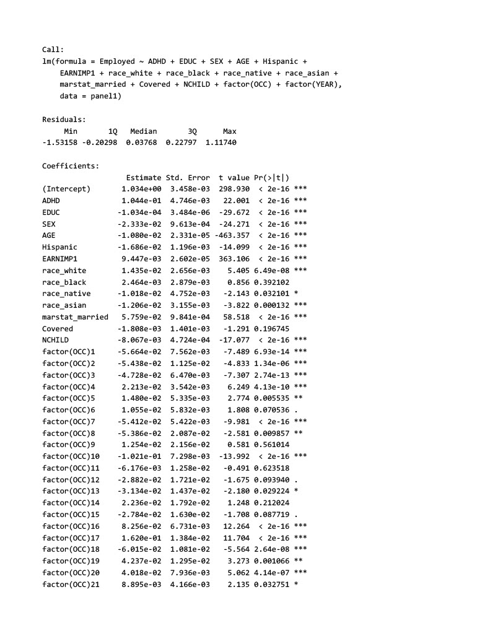

Table 4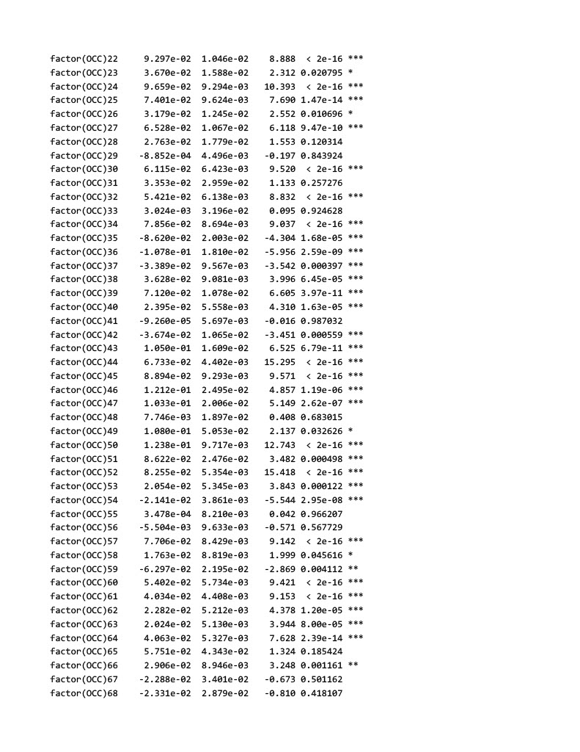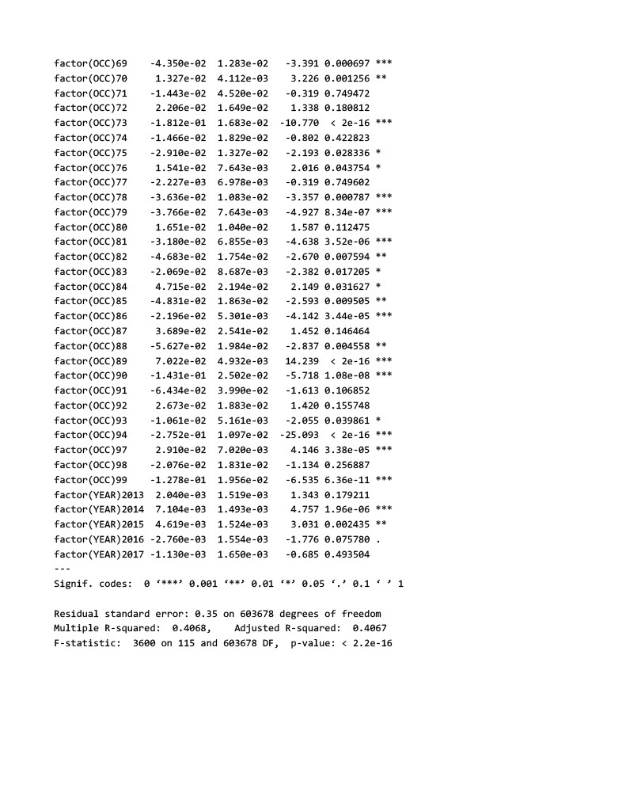

Table 5

Graph 1

